Cost-Benefit Analysis of Buying Non-Use Rights for Coal Mines

Joshua Muthu

University of Warwick

September 2024

## Abstract

Coal is the deadliest and dirtiest major energy source on the planet. Buying “non-use” rights for coal mines - the right to not exploit, but rather shutter, coal mines upon purchase, could reduce coal production. If there is a global market for non-use rights, marginally profitable mines can be bought, reducing the potential for supply leakage. I perform a cost-benefit analysis on non-use of coal mines in two countries where the supply of two different types of coal is currently marginally profitable: Indonesia and Australia. I find the benefit-cost ratio of buying the median Indonesian coal mine for a year of non-use is 21.00 (low and high estimates: 11.02 and 31.65), and equivalent ratio for the median Australian coal mine is 12.90 (low and high estimates: 6.76 and 19.43). Thus, I find that the purchase of one-year non-use rights for marginally profitable coal mines is both theoretically sound and practically justifiable.

## Introduction

Both the production and consumption of coal for energy generation incur large negative externalities upon society as a whole. Coal is the deadliest major source of energy worldwide, with at least 24.62 deaths from accidents and air pollution per terawatt-hour of electricity production (Ritchie, 2020). Both the mining and burning of coal have considerable health impacts, including increased risk of respiratory disease, cardiovascular disease, and cancer (Hendryx, Zullig and Luo, 2020). Coal also emits the most greenhouse gases (GHGs) of any energy source, with 970 tonnes of CO2-equivalent produced per gigawatt-hour of electricity, and thus is a major contributor to climate change (Ritchie, 2020). In fact, over 40% of global CO2 emissions are from coal; the world emitted 37.15bn tonnes of CO2 (tCO2) in 2022, of which 15.22bn were from coal (Ritchie, Rosado and Roser, 2020).

To reduce the welfare loss from these negative externalities, the equilibrium quantity of coal in the energy market has to fall. Many environmental policies have been proposed that affect demand for coal power (such as carbon taxes, cap-and-trade, and subsidising clean energy sources as substitutes) or the supply of it (such as Pigouvian taxes on coal extraction) (Collier and Venables, 2014).

However, all of these proposed policies fall prey to the free-rider problem. Emissions reduction is globally non-rival, because the benefits one country receives from reduced emissions does not diminish the benefits enjoyed by other countries. It is also non-excludable, because the benefits from lower emissions cannot be restricted to only the coalition countries, and is thus a global public good. If a coalition of countries enacted policies to reduce GHG emissions and air pollution, non-coalition countries would have an incentive to free-ride: they can enjoy the benefits of the coalition’s efforts to reduce emissions while avoiding having to bear the costs of emissions reductions themselves (Hoel, 1994).[1] For example, if a coalition unilaterally decides to reduce fossil fuel consumption, the global price for fossil fuels will fall, incentivising non-coalition countries to raise their consumption: this offsetting behaviour by non-coalition actors is known as leakage (Bohm, 1993).

Both supply- and demand-side policies risk leakage. However, Collier and Venables (2014) state that leakage will be reduced by using supply- (rather than demand-) side policies, if price elasticities of demand are high relative to elasticities of supply. They state that price elasticity of demand is indeed relatively higher, as there exist demand-side substitutes for coal (other energy sources), but no comparable supply-side substitutes (there is no technological link between reduced coal production and increased production of substitute energy sources): hence, supply-side policies reducing coal production are likely to be superior (Asheim et al., 2019; Collier and Venables, 2014).

Harstad (2012), drawing on Hoel (1994) and Bohm (1993), suggests a supply-side policy of purchasing non-use rights for fossil fuel deposits to correct for negative externalities - that is, the right of a purchaser to not exploit a deposit upon purchasing it, but rather to shutter it (at least temporarily). NGOs have successfully purchased non-use rights in several sectors, including for oil and gas leases, grazing permits, timber harvesting, water leasing, fishing permits, and hunting licences (Leonard et al., 2021). In its unaltered form, purchasing non-use rights for coal deposits would still be susceptible to leakage. However, by introducing a global market for coal deposits, non-use rights to marginally profitable coal mines can be acquired, thereby removing the incentive for non-coalition countries to increase supply.

I illustrate the above using a simple linear model from Harstad (2012). Assume that the marginal benefits from coal consumption, $B'$, and the marginal private costs, ${C'}_{0}$, are linear and identical for all countries. In the absence of any environmental policy, each country consumes and supplies at the free-market equilibrium $(x',p_{0})$, as shown in Figure 1. If a coalition of environmentally-conscious countries experiences a marginal external cost of $H'=p_{B}-p_{S}$ from emissions, then the free-market equilibrium incurs a deadweight loss of $α+β$. The socially optimal level of coal production is $x*<x'$. But if the coalition unilaterally reduces their consumption and production of coal to this level, the world price would rise. This would incentivise non-coalition countries to increase their supply of coal, returning to the suboptimal free-market equilibrium. This supply leakage thereby offsets the coalition’s efforts to reduce negative externalities.

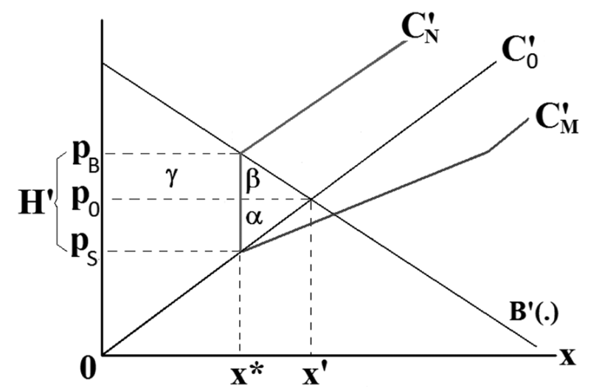

*Figure 1 (Harstad, 2012, p. 4). The coalition purchases marginally profitable coal deposits from non-coalition countries.*

However, by introducing a deposit market, the coalition will benefit from buying and preserving coal deposits from non-participating countries whenever the deposits have marginal extraction costs in the interval $(p_{S},p_{B})$. In this interval, the profit from exploiting the coal deposits is smaller than the coalition’s deadweight loss (i.e., the environmental harm from exploitation). Such a trade shifts the non-coalition countries’ supply curve to $C'_{N}$, and the coalition’s supply curve to $C'_{M}$. The non-coalition supply curve thus becomes locally inelastic, which allows the coalition to regulate its own supply of coal down to $x*$ without the risk of supply leakage. In this way, trade between coalition and non-coalition countries can achieve the socially optimal equilibrium of $(x*,p_{B})$, in line with the Coase theorem (Coase, 2013).[2]

Having established that it is viable, according to economic theory, to buy marginally profitable coal mines to reduce negative externalities, I want to examine the practicality of doing so. In this paper, I will conduct a cost-benefit analysis on buying the rights to preserve coal deposits for a year in countries where marginally profitable coal is extracted. Figures 2 and 3 below show the supply curves of low- and high-CV (caloric value) thermal coal in 2022.[3] Though low- and high-CV coal are close substitutes, they can be considered as separate markets, owing to the large price difference. As can be seen from where the 2023 price lines intersect the supply curves, the marginally profitable supply of low-CV coal comes from Indonesia, and the marginally profitable supply of high-CV coal comes from Australia. I therefore use data from both countries to inform my cost-benefit analysis. The full data sources and calculations are available in the accompanying Data and Calculations File.[4]

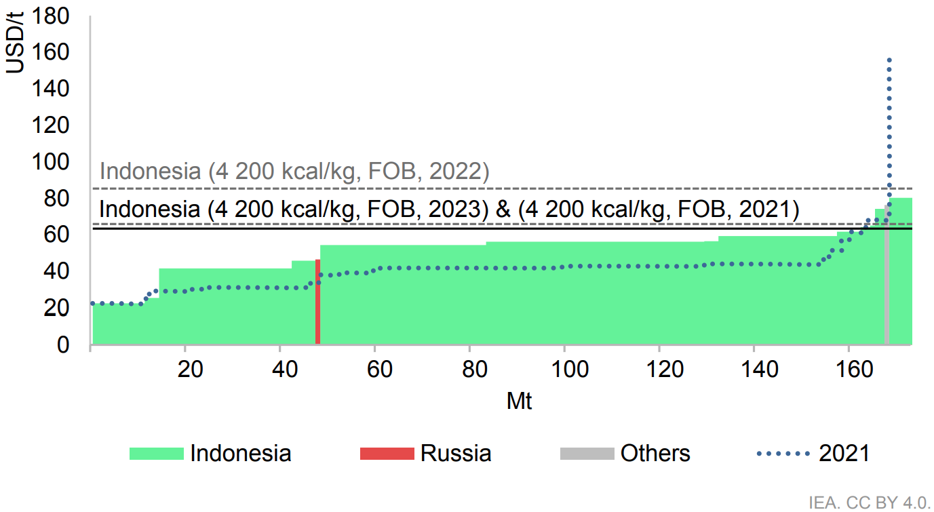

*Figure 2 (IEA, 2023a, p. 92). Indicative low-CV (< 4 500 kcal/kg) thermal coal supply curve 2022 and annual average prices of coal exported from Indonesia. The cost curves account for variable production costs, overburden removal, royalties, inland transport, and port usage fees.*

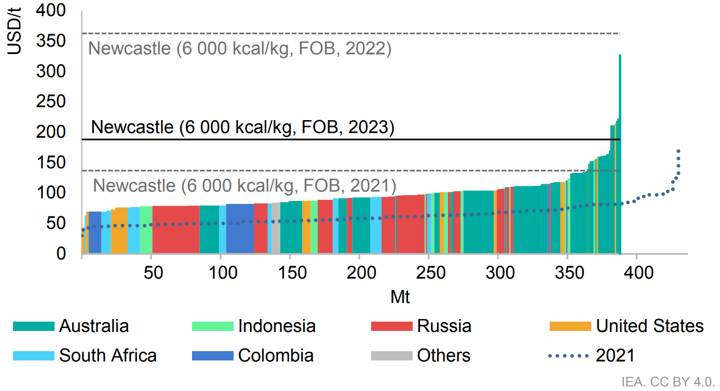

*Figure 3 (IEA, 2023a, p. 91). Indicative high-CV (> 5 700 kcal/kg) thermal coal supply curve 2022 and annual average price of coal exported from Newcastle, Australia. The cost curves account for variable production costs, overburden removal, royalties, inland transport, and port usage fees.*

There are several limitations to my analysis, some of which I will highlight from the outset. First, coal prices are volatile, as can be seen by the variation in annual average prices in Figures 2 and 3. Price changes could impact the cost-benefit calculus considerably (including the choice of marginally profitable reference countries). In this paper, I hope to provide indicative estimates of costs and benefits using, where possible, 2023 values. Second, my calculations consider the purchase of non-use rights for one year only. Because there are fixed costs, such as administrative and legal costs, associated with establishing non-use rights, longer-term non-use rights are likely to be more practical, which would alter the cost-benefit calculus (for example, requiring net present value calculations, and forecasts of future potential coal production). Third, the economic viability of, and demand for, coal relative to other power sources has been declining, and will continue to do so (IEA, 2023b). Thus, within a few years, the costs and benefits associated with purchasing non-use rights may have changed considerably. Fourth, Collier and Venables (2014) critique Harstad’s proposal on the grounds that citizens of countries where marginal coal mines are located would likely be opposed to the foreign purchase of coal mines for non-use. Indeed, there may even be regulation in place preventing such foreign ownership. My cost estimate accounts for the cost of paying foregone profits, direct and indirect employment, and government revenue, which may go some way towards reducing domestic opposition. However, as discussed below, I do not account for many foregone spillover effects, nor do I consider domestic political opposition.

## Cost estimate

In this section, I will estimate the total costs associated with buying a mine for a year of non-use in the two countries with marginally profitable coal production: Indonesia and Australia. Note that these costs are for a mine that has already been constructed, rather than an unimproved coalfield, the associated costs of which are likely to be very different. I split my cost estimates by the types of income that would otherwise have been received from an operating mine. Note that, unless otherwise indicated, $ refers to USD.[5]

**Cost of foregone profits (purchase price)**

Coal mining firms need to be compensated for foregone profits. This cost estimate would likely represent the direct cost of buying the mine from a firm for a year of non-use. This is because firms would only be willing to sell at a price equal to or higher than the profit they would expect to receive from operating the mine for a year.

The Coal 2023 report by the IEA estimates the profits were $19 per tonne of high-CV thermal coal in Indonesia in 2023 (IEA, 2023a, p. 100). I use the Global Energy Monitor’s Global Coal Mine Tracker (2024) to find the median production of all recorded coal mines in Indonesia: 0.3 megatons of coal per annum (Mtpa).[6] Thus the median mine makes a profit of $5.70m per year, which therefore represents the approximate value that would have to be paid to a mining firm to acquire an Indonesian mine for non-use for a year. Coal mining profits in Australia were higher, at $77 per tonne of high-CV thermal coal in 2023 (IEA, 2023a, p. 100). The median mine is larger, producing 3.78 Mtpa, for an estimated profit of $290.71m per year (Global Energy Monitor, 2024).[7] $290.71m thus represents the approximate purchase value of an Australian coal mine for a year of non-use.

**Cost of foregone employment**

Workers who would otherwise be employed in the mine experience a cost in the form of foregone wages. I also consider the cost of income support and retraining for displaced mine workers. I also estimate the cost of compensation of foregone indirect employment (i.e. labour that would have been employed indirectly if mining activity were to take place, such as transportation workers).

The median workforce size in actively producing Indonesian coal mines is 273, with an average monthly wage of IDR 4.94m, equivalent to an annual salary of $3,858.06 (BPS-Statistics Indonesia, 2024; Global Energy Monitor, 2024). Thus, I estimate the total annual wages foregone from non-use of an Indonesian mine to be $1.05m. In Australia, the median coal mine workforce size is 439.5, with average weekly earnings of AUD3,015.30, equivalent to an annual salary of around $100,560 (Australian Bureau of Statistics, 2024; Global Energy Monitor, 2024). Thus, I estimate the annual wages foregone from non-use of an Australian coal mine to be $44.20m.

To estimate the cost of retraining and supporting the workers who have lost out on potential employment due to non-use of the coal mine, I use estimates from Dolfin and Schochet (2012). They calculate the benefits and costs of the US Trade Adjustment Assistance (TAA) programme, which provides training, wage subsidies, and temporary income support to manufacturing workers who have experienced job loss due to foreign competition. Dolfin and Schochet estimate the total average discounted societal cost (net of the benefits enjoyed by the recipients) of the TAA to be $8,086 per participant (in 2006$), equivalent to $12,612.78 in 2024.[8] I assume that this estimate is representative of the cost of worker retraining for miners in Indonesia and Australia, which is likely an inaccurate assumption but which provides an indicative estimate of retraining and income support costs. Using the median numbers of mine workers as above, the retraining and support costs for occupationally displaced mine workers are $3.44m in Indonesia, and $5.54m in Australia.

Mandras and Salotti (2021, pp. 12-13) estimate the ratio of indirect to direct jobs in coal activities in the EU to be 0.64; that is, for every 100 directly employed people in the coal industry, there are 64 indirectly employed individuals. Applying this ratio to the median workforce sizes in Indonesia and Australia, and assuming the indirectly employed workers earn the same salaries as directly employed mine workers, then the cost of foregone indirect employment from a year of non-use is $0.67m for an Indonesian mine and $28.29m for an Australian one. Assuming that the workers who have lost out on indirect employment due to non-use also require retraining and support, the TAA cost estimate can again be used. The retraining and support costs for foregone indirectly employed labour amount to $2.20m for the median Indonesian mine and $3.55m for the median Australian mine.

The total cost of foregone employment therefore totals $7.37m for a year of non-use of a median Indonesian coal mine, and $81.57m for a year of non-use of a median Australian coal mine.

**Cost of foregone government revenue**

The government experiences a cost in terms of foregone revenue that they would have otherwise received, primarily in the form of royalties and taxes. The top rate of corporate income tax (CIT) applied to business profits in Indonesia for coal mining is 22%, while the rate in Australia for entities with an aggregated turnover of over AUD 50m is 30% (Australian Taxation Office, 2023; PricewaterhouseCoopers, 2023).[9] Using the estimates of profit from IEA (2023a, p. 100) as above ($19/tonne in Indonesia, and $77/tonne in Australia), the foregone CIT liability from a year of non-use is $1.25m from the median Indonesian coal mine, and $87.21m from the median Australian coal mine.

The price of Indonesian low-CV thermal coal is $64/tonne, so the corresponding royalty rate (which applies to coal with a sale value of under $70/tonne) is 20% (Christina, 2022; IEA, 2023a, p. 92).[10] Using the median mine production, the total foregone royalties liability from a year of non-use is $3.84m. The state of Queensland in Australia has some of the highest royalties in Australia, as well as the country’s largest coal resources, and thus provides a reasonable upper bound for the calculation of foregone royalties for non-use of an Australian mine (Geoscience Australia, 2024; IEA, 2023a). Applying the Queensland Government royalty rates to the Australian high-CV thermal coal price of $186/tonne, I find that $19.20 of royalties would be paid per tonne of coal sold (IEA, 2023a, p. 91; Queensland Revenue Office, 2024).[11] Thus, a year of non-use of the median Australian coal mine would forego $72.49m in royalties.

The total foregone government revenue for a year of non-use, therefore, is $5.09m for the median Indonesian coal mine producing marginally profitable low-CV thermal coal, and $159.70m for the median Australian mine producing marginally profitable high-CV thermal coal. Note that my calculations only account for foregone CIT and royalties. They do not account for other taxes, such as land and building taxes, export duties, and VAT charged on domestic sales, and thus represent an underestimate of foregone government revenue (PricewaterhouseCoopers, 2023).

**Total costs**

Adding up the costs of foregone profits, employment, and government revenue, I calculate that a year of non-use of a median Indonesian coal mine producing marginally profitable low-CV thermal coal has a total cost of $18.17m. For a median Australian mine producing marginally profitable high-CV thermal coal, the total cost is $531.99m.

My cost calculations further assume that, because the coal deposits being purchased are only marginally profitable, there is no effect on the global price of coal or energy. However, because of barriers to trade and market frictions, it is likely that local energy prices would in fact rise, which would incur accompanying spillover costs. I also do not quantify the cost of foregone spillover effects from, for example, capital investment into mines (such as technology diffusion and improved infrastructure) and mining employment (such as knowledge transfer and community cohesion). I also do not estimate the administrative and legal costs of renting the coal mine. Leases for the non-use of mines are unusual and unconventional, and are therefore likely to require more complex negotiations and contract drafting processes relative to normal mining leases.

## Benefit estimate

In this section, I will estimate the benefits of renting a coal mine for non-use for a year. Epstein et al. (2011) estimate the total externalities associated with the entire life cycle of coal, from extraction to combustion. The external cost estimate largely consists of the health effects (e.g. carcinogens, public health burden, and impact of mercury emissions) and environmental impacts (e.g. methane, CO2, N2O, and black carbon emissions) of coal. The cost of coal per kilowatt-hour of electricity is estimated to be 17.84 cents (2008$) (with low and high estimates of 9.36 and 26.89 ¢/kWh) (Epstein et al., 2011, p. 11). The authors state that these figures do not represent the full external cost of coal, and are therefore underestimates. The figures omit, for example, coal’s impact on ecological systems, some morbidity from air pollution, and direct risks and hazards from waste products.

High-CV Newcastle (Australia) coal is 6,000 kcal/kg, while low-CV Indonesian coal is 4,200 kcal/kg (IEA, 2023a, pp. 91-92). Using Epstein et al.’s calculations, I therefore find that, in 2024$, the external cost of Australian high-CV coal is $1,817.96/tonne (low and high estimates: $953.21/tonne and $2,738.30/tonne), and the external cost of Indonesian low-CV coal is $1,271.99/tonne (low and high estimates: $667.23/tonne and $1,916.77/tonne). Note that these cost calculations do not account for the fact that lower-quality coal has greater health impacts. Lignite (brown coal), a more impure and lower-CV type of coal, is associated with a higher death rate than other types of coal (Ritchie, 2020). It is therefore likely that, for lower-CV coal, the above external cost calculations are an underestimate.

As mentioned above, the median production of Indonesian and Australian coal mines is 0.3 Mtpa and 3.78 Mtpa, respectively. Therefore the total benefits from non-use of coal mines for one year, in terms of averting the above external costs, would be $381.60m in Indonesia (low and high: $200.17m and $575.03m) and $6,860.70m in Australia (low and high: $3,598.84m and $10,338.44m).

## Benefit-cost ratios and discussion

The overall benefit-cost ratios (BCRs) are presented in Table 1 below.

|  | Indonesia | | | Australia | | |
| --- | --- | --- | --- | --- | --- | --- |
|  | Low estimate | Central estimate | High estimate | Low estimate | Central estimate | High estimate |
| Total benefit, $m | 200.17 | 381.60 | 575.03 | 3,598.84 | 6,860.70 | 10,338.44 |
| Total cost, $m | 18.17 | | | 531.99 | | |
| **Benefit-cost ratio** | **11.02** | **21.00** | **31.65** | **6.76** | **12.90** | **19.43** |

*Table 1. Benefit-cost ratios for buying the median coal mine in Indonesia and Australia for a year of non-use, split by low, central, and high estimates of total benefit.*

The central BCR estimate of buying the median Indonesian coal mine, which is a proxy for a marginally profitable low-CV (4,200 kcal/kg) mine, for a year of non-use is 21.00 (low and high estimates: 11.02 and 31.65).

The central BCR estimate of buying the median Australian coal mine, which is a proxy for a marginally profitable high-CV (6,000 kcal/kg) mine, for a year of non-use is 12.90 (low and high estimates: 6.76 and 19.43).

For reference, I list a selection of other BCRs in Table 2.

| Project | BCR | Source |
| --- | --- | --- |
| Distributing long-lasting insecticidal nets in Ghana to achieve 90% coverage of households | 44 | Nketiah-Amponsah et al. (2020, p. I) |
| HS2 Phase One (high-speed railway between London and the West Midlands, including Birmingham) | 1.7 | Economic Affairs Committee (2015, p. 100) |
| Forestation next to bodies of water to reduce flood risk (Scotland) | 2.8 | Dittrich et al. (2018, p. 8) |
| 81 US public transit systems | 1.34 | Harford (2006, pp. 12-13) |
| Retrofitting existing private-sector residential buildings in the US to reduce natural hazard risk | 4 | Multi-Hazard Mitigation Council (2019, p. 42) |
| 1990 Clean Air Act Amendments (USA) | 32  *(5% and 95% estimates: 4 and 92)* | U.S. Environmental Protection Agency (2011, p. 3) |
| Global health co-benefits from air pollution and mitigation costs of the Paris Agreement | 1.4-2.45 *(depending on the scenario)* | Markandya et al. (2018) |
| COVID-19 vaccination in Catalonia | 3.4 *(low- and high-effectiveness estimates: 2.7 and 4.1)* | López et al. (2021, p. 6) |
| COVID-19 asymptomatic mass  testing strategy in Catalonia | 1.20 | López Seguí et al. (2021, p. 5) |
| Continuing the Expanded Program on Immunization during the COVID-19 pandemic in Africa | 125 *(value of statistical life year approach)* | Watts, Mak and Patenaude (2022, p. 8) |

*Table 2. Selection of BCRs of various projects.*

My estimates of the BCR of coal mine non-use are below the BCR of the 1990 Clean Air Act Amendments in the USA, and considerably below those of public health interventions in Africa. However, they are higher than, for example, BCRs of public transport projects and the COVID-19 vaccination and mass testing campaigns in Catalonia.

Thus, according to my calculations, the purchase of one-year non-use rights for marginally profitable coal mines is sound from the perspective of economic theory and justifiable in practical terms.

## Reference list

Asheim, G.B., Fæhn, T., Nyborg, K., Greaker, M., Hagem, C., Harstad, B., Hoel, M.O., Lund, D. and Rosendahl, K.E. (2019). The case for a supply-side climate treaty. *Science*, [online] 365(6451), pp.325–327. doi:<https://doi.org/10.1126/science.aax5011>.

Australian Bureau of Statistics (2024). *Average Weekly Earnings, Australia, May 2024*. [online] Australian Bureau of Statistics. Available at:<https://www.abs.gov.au/statistics/labour/earnings-and-working-conditions/average-weekly-earnings-australia/latest-release> [Accessed 7 Sep. 2024].

Australian Taxation Office (2023). *Tax rates 2023–24*. [online] ato.gov.au. Available at:<https://www.ato.gov.au/tax-rates-and-codes/company-tax-rates/tax-rates-2023-24> [Accessed 8 Sep. 2024].

Bohm, P. (1993). Incomplete International Cooperation to Reduce CO2 Emissions: Alternative Policies. *Journal of Environmental Economics and Management*, [online] 24(3), pp.258–271. doi:<https://doi.org/10.1006/jeem.1993.1017>.

BPS-Statistics Indonesia (2024). *Average of Net Wage/Salary per Month (rupiahs) of Employee by Age Group and Main Industry, 2024*. [online] bps.go.id. Available at:<https://www.bps.go.id/en/statistics-table/1/MjI0OSMx/average-of-net-wage-salary-per-month--rupiahs--of-employee-by-age-group-and--main-industry--2024.html> [Accessed 7 Sep. 2024].

Christina, B. (2022). *Indonesia raises coal royalty rate to range of 14% to 28%*. [online] Reuters. Available at:<https://www.reuters.com/article/business/energy/indonesia-raises-coal-royalty-rate-to-range-of-14-to-28-idUSL2N2WG03W/> [Accessed 8 Sep. 2024].

Coase, R.H. (2013). The Problem of Social Cost. *The Journal of Law and Economics*, [online] 56(4), pp.837–877. doi:<https://doi.org/10.1086/674872>.

Collier, P. and Venables, A.J. (2014). Closing coal: economic and moral incentives. *Oxford Review of Economic Policy*, [online] 30(3), pp.492–512. doi:<https://doi.org/10.1093/oxrep/gru024>.

Dittrich, R., Ball, T., Wreford, A., Moran, D. and Spray, C.J. (2018). A cost-benefit analysis of afforestation as a climate change adaptation measure to reduce flood risk. *Journal of Flood Risk Management*, 12(4). doi:<https://doi.org/10.1111/jfr3.12482>.

Dolfin, S. and Schochet, P.Z. (2012). *The Benefits and Costs of the Trade Adjustment Assistance (TAA) Program Under the 2002 Amendments*. [online] *U.S. Department of Labor*. Available at:<https://www.dol.gov/sites/dolgov/files/ETA/publications/ETAOP_2013_09.pdf> [Accessed 12 Aug. 2024].

Economic Affairs Committee (2015). *The Economics of High Speed 2*. [online] *UK Parliament*. Available at:<https://publications.parliament.uk/pa/ld201415/ldselect/ldeconaf/134/134.pdf>.

Epstein, P.R., Buonocore, J.J., Eckerle, K., Hendryx, M., Stout, B.M., Heinberg, R., Clapp, R.W., May, B., Reinhart, N.L., Ahern, M.M., Doshi, S.K. and Glustrom, L. (2011). Full cost accounting for the life cycle of coal. *Annals of the New York Academy of Sciences*, [online] 1219(1), pp.73–98. doi:<https://doi.org/10.1111/j.1749-6632.2010.05890.x>.

Geoscience Australia (2024).  *Australia’s Identified Mineral Resources 2023*. [online] Available at:<https://ecat.ga.gov.au/geonetwork/srv/eng/catalog.search#/metadata/149056>.

Global Energy Monitor (2024). *Global Coal Mine Tracker*. [online] Global Energy Monitor. Available at:<https://globalenergymonitor.org/projects/global-coal-mine-tracker/> [Accessed 7 Sep. 2024].

Harford, J.D. (2006). Congestion, pollution, and benefit-to-cost ratios of US public transit systems. *Transportation Research Part D: Transport and Environment*, [online] 11(1), pp.45–58. doi:<https://doi.org/10.1016/j.trd.2005.09.001>.

Harstad, B. (2012). Buy Coal! A Case for Supply-Side Environmental Policy. *Journal of Political Economy*, [online] 120(1), pp.77–115. doi:<https://doi.org/10.1086/665405>.

Hendryx, M., Zullig, K.J. and Luo, J. (2020). Impacts of Coal Use on Health. *Annual Review of Public Health*, [online] 41(1), pp.397–415. doi:<https://doi.org/10.1146/annurev-publhealth-040119-094104>.

Hoel, M. (1994). Efficient Climate Policy in the Presence of Free Riders. *Journal of Environmental Economics and Management*, [online] 27(3), pp.259–274. doi:<https://doi.org/10.1006/jeem.1994.1038>.

IEA (2023a). *Coal 2023*. [online] IEA. Available at:<https://www.iea.org/reports/coal-2023> [Accessed 13 Jul. 2024].

IEA (2023b). *Global coal demand expected to decline in coming years*. [online] IEA. Available at:<https://www.iea.org/news/global-coal-demand-expected-to-decline-in-coming-years> [Accessed 24 Jul. 2024].

International Joint Commission (1991). *Canada-United States Air Quality Agreement*. [online] International Joint Commission. Available at:<https://ijc.org/en/mission/air-quality-agreement> [Accessed 12 Sep. 2024].

Leonard, B., Regan, S., Costello, C., Kerr, S., Parker, D.P., Plantinga, A.J., Salzman, J., Kerry, S.V. and Stoellinger, T. (2021). Allow ‘nonuse rights’ to conserve natural resources. *Science*, [online] 373(6558), pp.958–961. doi:<https://doi.org/10.1126/science.abi4573>.

López Seguí, F., Estrada Cuxart, O., Mitjà i Villar, O., Hernández Guillamet, G., Prat Gil, N., Maria Bonet, J., Isnard Blanchar, M., Moreno Millan, N., Blanco, I., Vilar Capella, M., Català Sabaté, M., Aran Solé, A., Argimon Pallàs, J.M., Clotet, B. and Ara del Rey, J. (2021). A Cost-Benefit Analysis of the COVID-19 Asymptomatic Mass Testing Strategy in the North Metropolitan Area of Barcelona. *International Journal of Environmental Research and Public Health*, [online] 18(13), pp.7028–7028. doi:<https://doi.org/10.3390/ijerph18137028>.

López, F., Català, M., Prats, C., Estrada, O., Oliva, I., Prat, N., Isnard, M., Vallès, R., Vilar, M., Clotet, B., Maria Argimon, J., Aran, A. and Ara, J. (2021). A Cost–Benefit Analysis of COVID-19 Vaccination in Catalonia. *Vaccines*, [online] 10(1), pp.59–59. doi:<https://doi.org/10.3390/vaccines10010059>.

Mandras, G. and Salotti, S. (2021). *Indirect jobs in activities related to coal, peat and oil shale: A RHOMOLO-IO analysis on the EU regions*. [online] *Joint Research Centre*. Joint Research Centre. Available at:<https://joint-research-centre.ec.europa.eu/system/files/2022-01/jrc127463.pdf> [Accessed 7 Sep. 2024].

Markandya, A., Sampedro, J., Smith, S.J., Van Dingenen, R., Pizarro-Irizar, C., Arto, I. and González-Eguino, M. (2018). Health co-benefits from air pollution and mitigation costs of the Paris Agreement: a modelling study. *The Lancet Planetary Health*, [online] 2(3), pp.e126–e133. doi:<https://doi.org/10.1016/s2542-5196(18)30029-9>.

Multi-Hazard Mitigation Council (2019). *Natural Hazard Mitigation Saves: 2019 Report*. [online] National Institute of Building Sciences. Available at:<https://www.nibs.org/projects/natural-hazard-mitigation-saves-2019-report> [Accessed 11 Sep. 2024].

Nketiah-Amponsah, E., Silal, S., Awine, T. and Wong, B. (2020). *Cost Benefit Analysis of Selected Malaria Interventions in Ghana*. [online] *Copenhagen Consensus Center*. Ghana Priorities, Copenhagen Consensus Center. Available at:<https://copenhagenconsensus.com/sites/default/files/gp_malaria_-_final.pdf> [Accessed 11 Sep. 2024].

PricewaterhouseCoopers (2023). *Mining Taxes Summary Tool*. [online] PwC. Available at:<https://www.pwc.com/gx/en/industries/energy-utilities-resources/mining-metals/mining-taxes-summary-tool.html> [Accessed 31 Jul. 2024].

Queensland Revenue Office. (2024). *Mineral royalty rates - Queensland Revenue Office*. [online] Available at:<https://qro.qld.gov.au/royalty/calculate-mineral/rates/> [Accessed 4 Aug. 2024].

Ritchie, H. (2020). *What Are the Safest and Cleanest Sources of energy?* [online] Our World in Data. Available at:<https://ourworldindata.org/safest-sources-of-energy>.

Ritchie, H., Rosado, P. and Roser, M. (2020). *CO2 emissions by fuel*. [online] Our World in Data. Available at:<https://ourworldindata.org/emissions-by-fuel#article-citation> [Accessed 12 Sep. 2024].

U.S. Environmental Protection Agency (2011). *The Benefits and Costs of the Clean Air Act from 1990 to 2020*. [online] *United States Environmental Protection Agency*. Available at:<https://www.epa.gov/sites/default/files/2015-07/documents/fullreport_rev_a.pdf> [Accessed 11 Sep. 2024].

Watts, E., Mak, J. and Patenaude, B. (2022). Benefit-Cost Ratios of Continuing Routine Immunization During the COVID-19 Pandemic in Africa. *Journal of Benefit-Cost Analysis*, [online] 13(1), pp.91–106. doi:<https://doi.org/10.1017/bca.2021.13>.

1. While the costs of air pollution are generally borne more locally than the costs of GHG emissions, they can also have transnational impacts that give rise to similar free-riding dynamics, for example transboundary air pollution in the USA and Canada (International Joint Commission, 1991).
2. Harstad (2012) also describes a more complex non-linear model, drawing on Hoel (1994), which demonstrates a similar outcome.
3. Caloric value is a measure of coal’s energy content per unit mass. Thermal coal is the type of coal used for power generation (e.g. in coal-fired power stations).
4. Permalinked here: <https://github.com/j-muthu/cba-coal-mine-non-use/blob/f0687da9c95adef164a6fff87f424248d7d1ee54/CBA%20of%20Buying%20Non-Use%20Rights%20for%20Coal%20Mines%20-%20Data%20and%20Calculations%20File.xlsx>.
5. Currencies have been converted to USD at September 2024 prices using <https://www.xe.com/currencyconverter/>.
6. Note that the Global Coal Mine Tracker only includes mines with a production of at least 1 Mtpa, with smaller mines included at discretion. Therefore estimates of median coal mine production are likely to be overestimates.
7. Again, this is likely to be an overestimate of median coal mine production - see the note above.
8. I use the Federal Reserve Bank of Minneapolis’ Inflation Calculator to convert to 2024$: <https://www.minneapolisfed.org/about-us/monetary-policy/inflation-calculator>.
9. As the median Australian coal mine produces 3.78 Mtpa, and the price of high-CV coal is $186/tonne, the median mine’s revenue is $702m, well over the aggregate turnover threshold of AUD50m, and therefore is subject to a 30% CIT.
10. This yields a royalty payment of $12.80/tonne, which is less than, but close to, the average royalties per tonne in the Indonesian province of Central Kalimantan in 2023, 14.1/tonne (IEA, 2023a, p. 96). Out of the provinces selected in IEA (2023a), Central Kalimantan had the highest royalties.
11. This is considerably less than the average royalty costs in Queensland of $34/tonne in 2023 (IEA, 2023a, p. 96). I suspect this is because a large proportion (35.54% in 2023) of Australian coal production is metallurgical coal (used in blast furnaces to produce steel), which has a much higher sale price than thermal coal and lignite (which are used for power generation) (IEA, 2023a, pp. 115-116). Note, however, that metallurgical coal only represents around 13% of global coal production and consumption, with thermal coal and lignite accounting for the other 87% (IEA, 2023a, pp. 114-116).